**WEEK – 5 : HANDS-ON EXERCISE**

**Microservices with SpringBoot3 and Spring Cloud**

**Exercise 1: Creating Microservices for account and loan**

**Scenario:**

You are building a Banking System with two microservices:

* Account Microservice: Returns account details for a customer.
* Loan Microservice: Returns loan details for a customer.

**Step 1: Project Setup**

* **Account Microservice**

**1. Generate Project**

* Use: <https://start.spring.io>
* Group: com.cognizant
* Artifact: account
* Dependencies:
  + Spring Web
  + DevTools

**2. Setup Project**

* Extract ZIP into microservice folder.
* Import account folder in Eclipse.

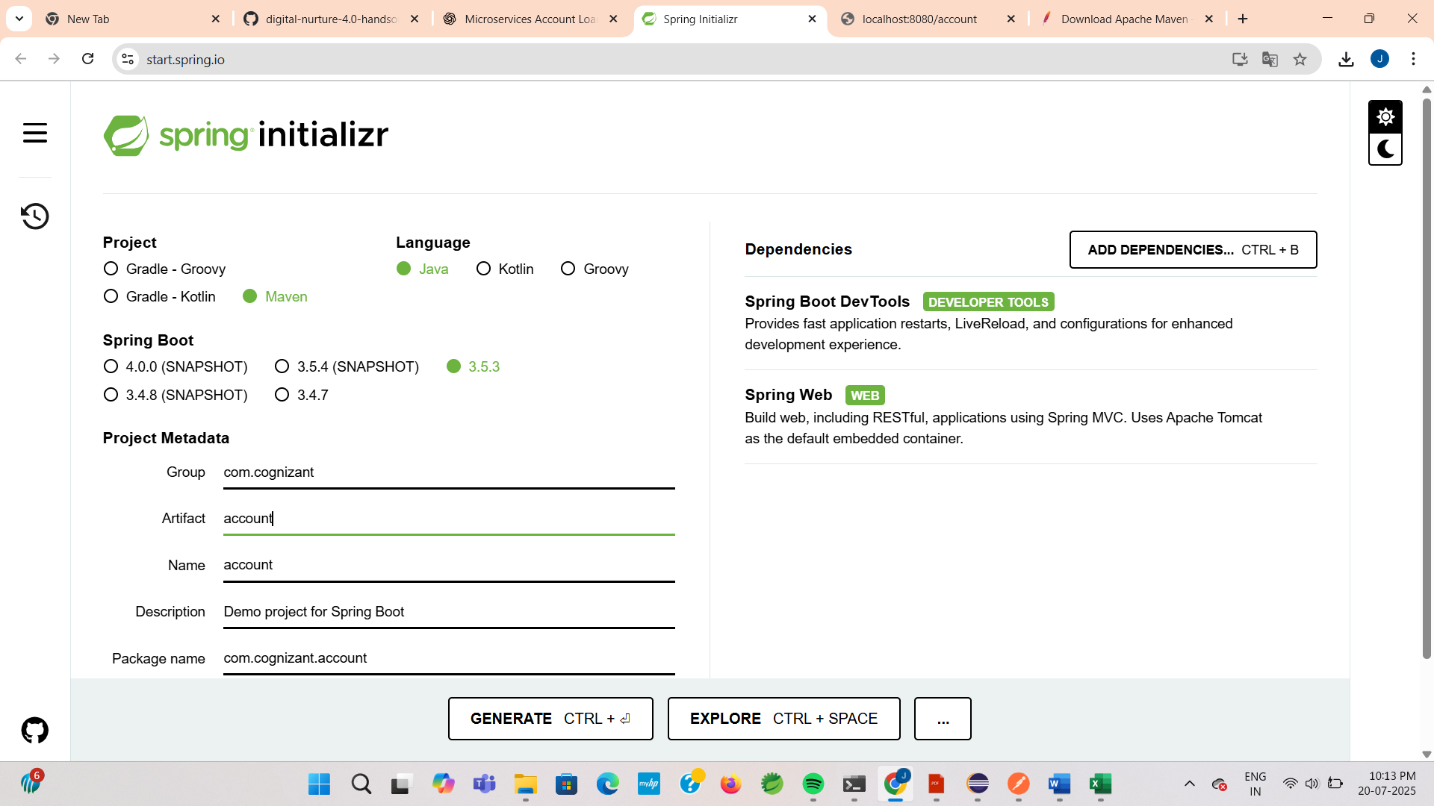

**AccountApplication.java:**

**CODE:**

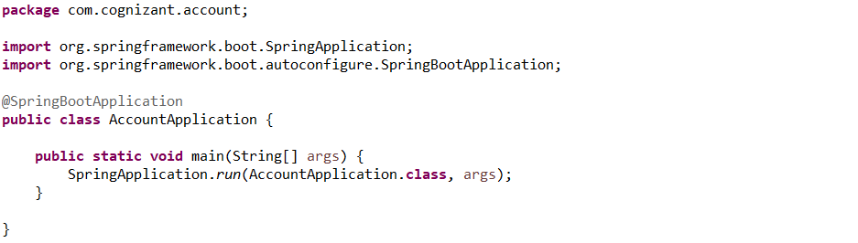

**AccountController.java**

**CODE:**

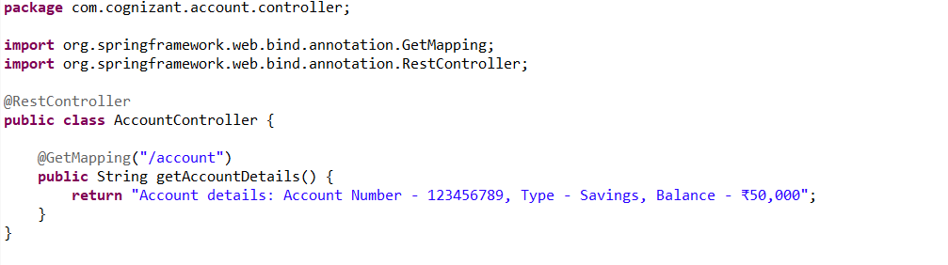

**Account.java:**

**CODE:**

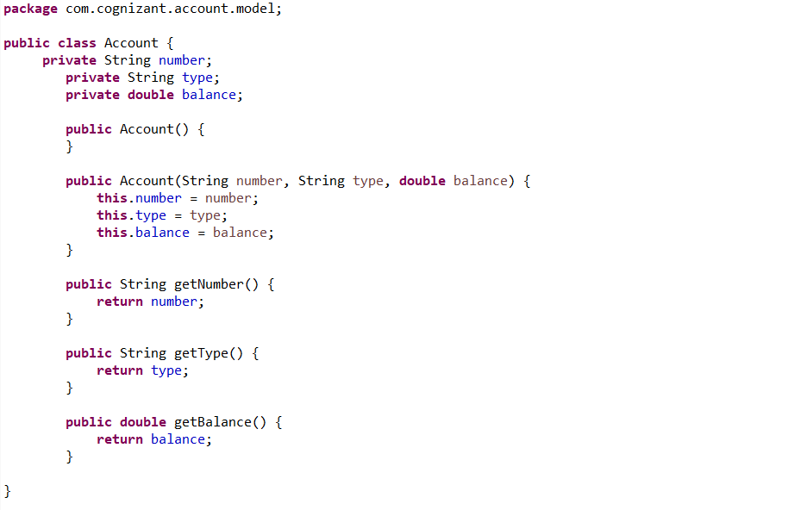

**Step 4: Running the Application**

**OUTPUT:**

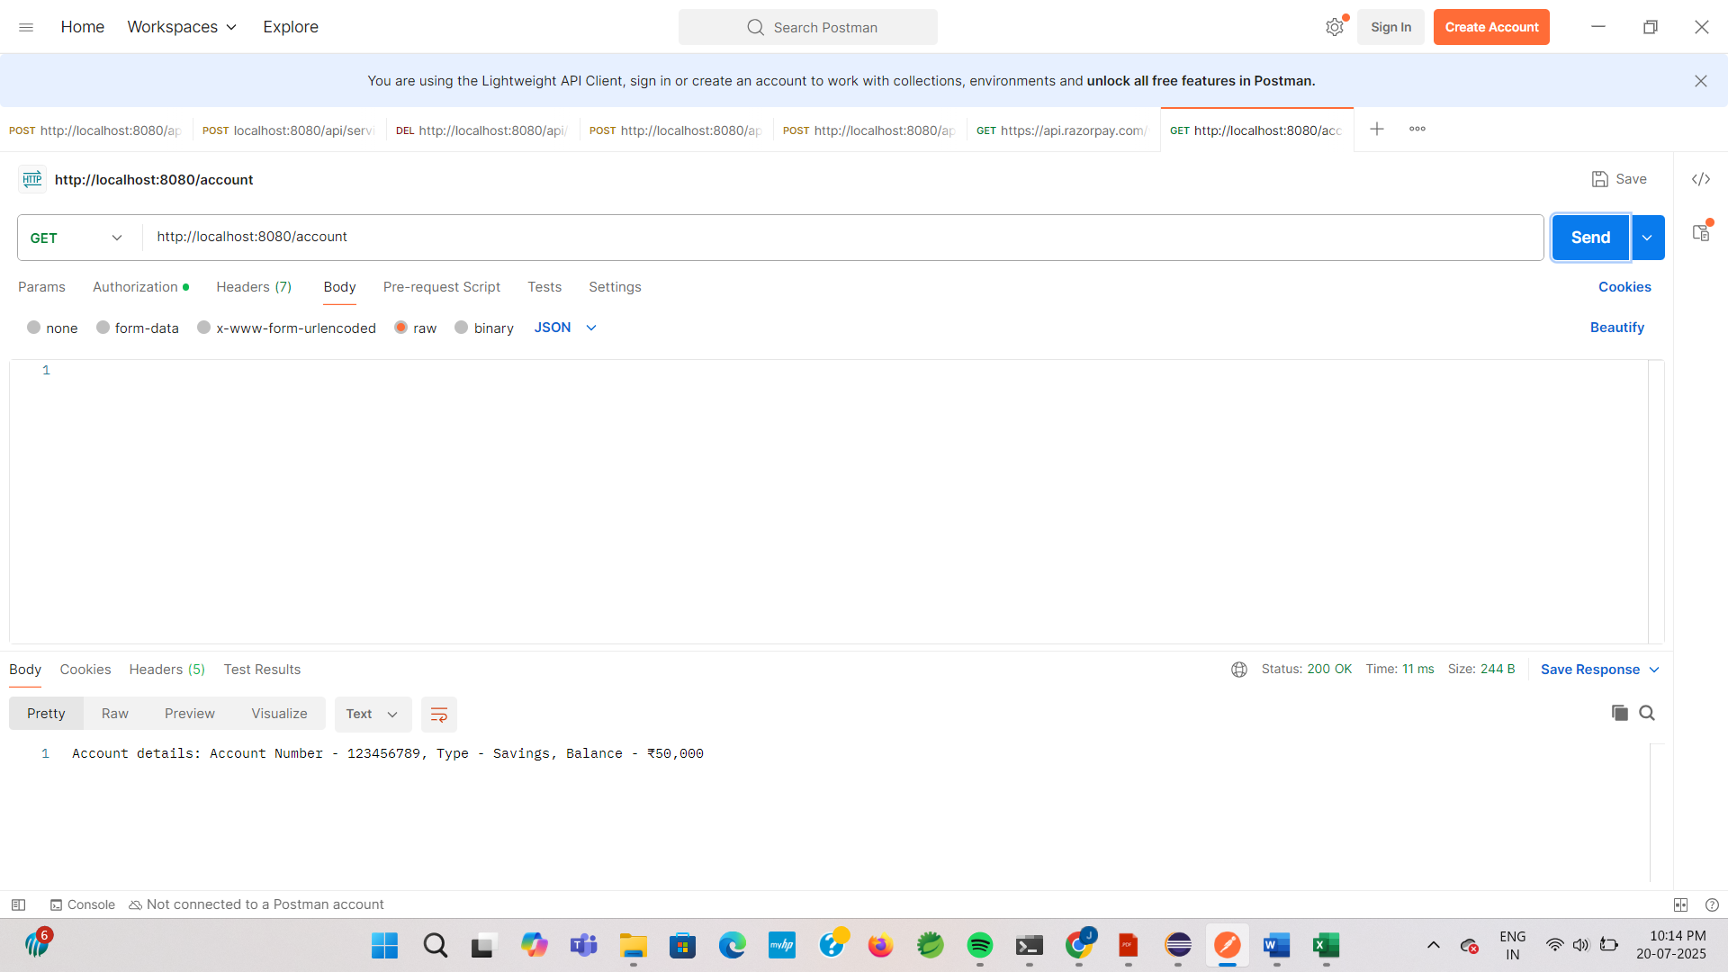

* **Loan Microservice**

1. **Generate Project**

* Use: <https://start.spring.io>
* Group: com.cognizant
* Artifact: loan
* Add the dependencies same as previous.

**2. Setup Project**

* Extract ZIP into microservice folder.
* Import account folder in Eclipse.

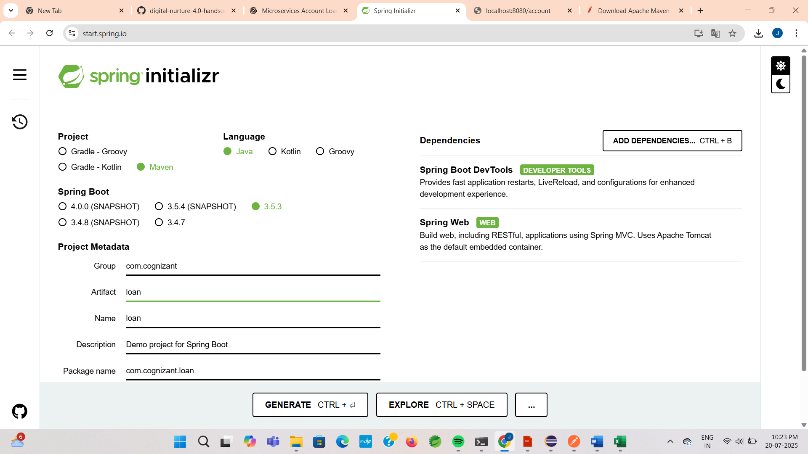

**LoanApplication.java:**

**CODE:**

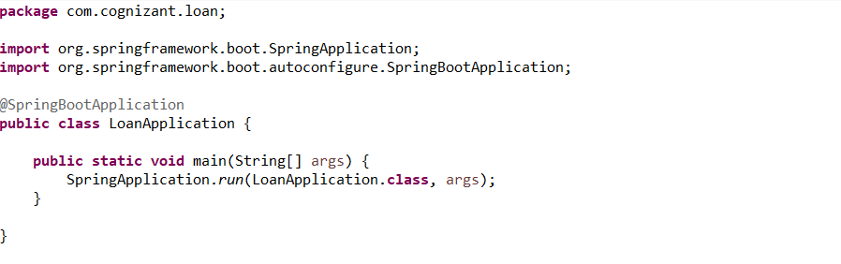

**LoanController.java:**

**CODE:**

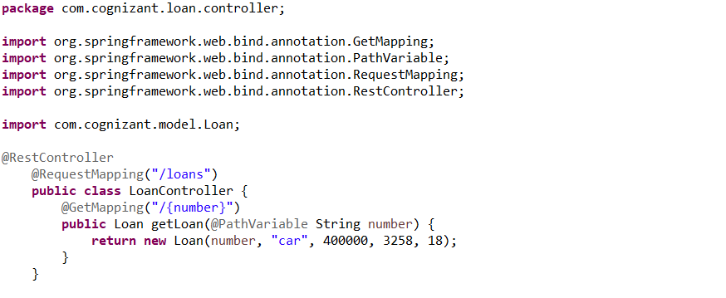

**Loan.java:**

**CODE:**

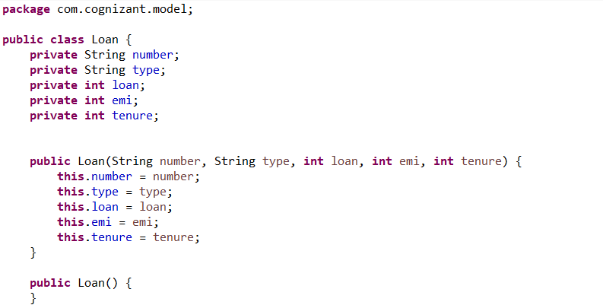

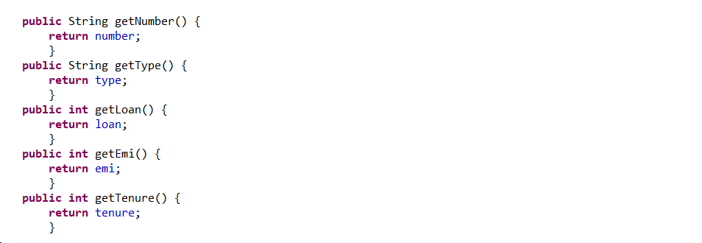

**OUTPUT:**

